ONEWAY SA BY RES
/STATISTICS DESCRIPTIVES HOMOGENEITY WELCH
/PLOT MEANS
/MISSING ANALYSIS.

Oneway

Notes
Output Created |  | 06-May-2019 00:04:36
Comments
Input | Active Dataset | DataSet0
Input | Filter | <none>
Input | Weight | <none>
Input | Split File | <none>
Input | N of Rows in Working Data File | 30
Missing Value Handling | Definition of Missing | User-defined missing values are treated as missing.
Missing Value Handling | Cases Used | Statistics for each analysis are based on cases with no missing data for any variable in the analysis.
Syntax |  | ONEWAY SA BY RES  /STATISTICS DESCRIPTIVES HOMOGENEITY WELCH  /PLOT MEANS  /MISSING ANALYSIS.
Resources | Processor Time | 00 00:00:00.156
Resources | Elapsed Time | 00 00:00:00.169

[DataSet0]

Descriptives
 | N | Mean | Std. Deviation | Std. Error | 95% Confidence Interval for Mean
 |  |  |  |  | Lower Bound | Upper Bound
1360x768 | 7 | 17.1429 | 6.41427 | 2.42437 | 11.2106 | 23.0751
1920x1080 | 15 | 26.6000 | 18.50405 | 4.77773 | 16.3528 | 36.8472
800x600 | 8 | 34.8750 | 16.53082 | 5.84453 | 21.0549 | 48.6951
Total | 30 | 26.6000 | 16.74062 | 3.05640 | 20.3490 | 32.8510

Descriptives
 | Minimum | Maximum
1360x768 | 5.00 | 24.00
1920x1080 | 6.00 | 67.00
800x600 | 18.00 | 62.00
Total | 5.00 | 67.00

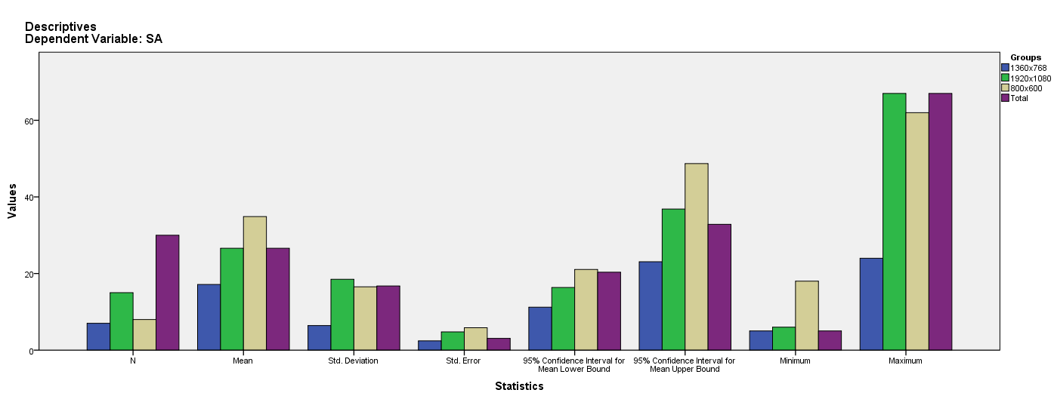

Test of Homogeneity of Variances
SA
Levene Statistic | df1 | df2 | Sig.
2.514 | 2 | 27 | .100

ANOVA
SA
 | Sum of Squares | df | Mean Square | F | Sig.
Between Groups | 1173.868 | 2 | 586.934 | 2.279 | .122
Within Groups | 6953.332 | 27 | 257.531
Total | 8127.200 | 29

Robust Tests of Equality of Means
SA
 | Statisticª | df1 | df2 | Sig.
Welch | 4.572 | 2 | 15.361 | .028
a. Asymptotically F distributed.

Means Plots

